Headteacher: Neil Small
Deputy Headteacher: Carol Collins
SENCO: Sam Butler

Special Educational Needs Policy

Reviewed: September 2018
Review: Annually

INTRODUCTION
This document is a statement of the aims, principles and strategies for special educational needs at Seymour Primary School. It complies with the statutory requirements laid out in the SEND code of practice 0 – 25 (2015) and has been written with reference to the following guidance and documents:
- Equality Act 2010: advice for schools DfE Feb 2013
- SEND Code of Practice 0 – 25 years (2015)
- Schools SEN Information Report Regulations (2014)
- Statutory Guidance on Supporting pupils at school with medical conditions (April 2014)
- The National Curriculum in England Key Stage 1 and 2 framework document (2014)
- Children and Families bill (2014)
- Safeguarding, Behaviour, Accessibility Policy
- Teachers Standards (2012)
- Education Endowment Foundation (2016)

The person responsible for managing Seymour School’s response to the provision that we make for children and young people with SEND is Mrs Sam Butler (BEd hons; PGCPP:NASENCo). Mrs Butler is a member of the senior management team.

At Seymour, all children, regardless of any learning difficulties or disabilities that they may have are encouraged to aim high, expand their minds, and develop self-belief. We work hard to raise expectations for all our pupils, and encourage them to be proud of their achievements.
We are committed to developing inclusive practice: every teacher is a teacher of every child, including those with SEND.

Being truly inclusive, means that we aim to remove any barriers that may prevent our pupils access learning and social opportunities in school. We do this by:
- Recognising that different children have different needs and interests, and that these may change over time
- Adapting what we do to meet the learning, physical, social and emotional needs of all children
- Adapting the environment to meet the learning, physical, social and emotional needs of all children
- Celebrating difference and encouraging positive interactions amongst all school members

Our aim is therefore to:
- Identify and assess individual pupils' needs as early as possible
- Match the provision of the curriculum to the needs of individual pupils
- Ensure all pupils experience a broad, balanced, relevant and differentiated curriculum
- Structure teaching groups in order to match as closely as possible the needs of the pupils
- Ensure appropriate and relevant information is available in order to address the evolving needs of all pupils
- Ensure that all pupils, staff, governors and parents/carers are aware of the special needs provision within the school and work in partnership
- Ensure individual pupils and staff receive appropriate support to meet identified special needs
- Integrate those pupils with special educational needs as fully as possible within the framework of the school
What we do to achieve our aim
Seymour Primary School adopts a graduated approach to managing inclusion, with the child at the centre of everything that we do. This approach is recommended in the SEND code of practice (2015) and can be applied to all aspects of inclusion.
Pupils and their parents are the centre of all inclusion support, and their views and wishes will be taken into account at every step.

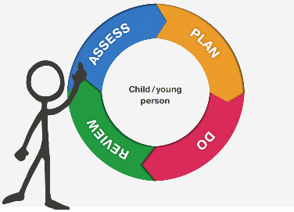

The Graduated Approach to managing SEND
Step 1: Assess
Identification of Special Educational Needs or Disabilities
Early identification of SEND enables the school to plan specific support and adaptations, thus removing any barriers that may prevent a child from the opportunities within school.
Recent legislation (SEND Code of Practice 2015) describes a single category of support called SEN Support with four main areas of need:

- Communication and Interaction (C&I)
- Cognition and Learning (C&L)
- Social, Emotional and Mental Health (SEMH)
- Sensory and Physical (S&P)

A child is likely to be identified as having SEND if they meet one or more of the following criteria:
- They have “a learning difficulty or disability which calls for special educational provision to be made for him or her” (SEN Code of Practice 2015)
- They have an identified “disability which prevents or hinders him or her from making use of facilities of a kind generally provided for others of the same age in mainstream” (SEN Code of Practice 2015)
- Their attainment in September is 2 or more bands below Age Related Expectations (ARE) in two or more core subjects
- They are EAL (English as an Additional Language) speakers, have been in school for at least one year and have failed to meet ARE and/or failed to make progress in two or more subjects, thus indicating the likelihood of additional learning needs
Parents are informed if their child has been identified as having SEND.
Assessments that support the identification of SEND

Early identification is vital. Many of the children who join us have already been in early education and in many cases, join us with their needs already assessed. All children are assessed when they enter our school, so that we can build upon their prior learning. We use this information to provide starting points for the development of an appropriate curriculum for all our children.

Seymour Primary School has a rigorous assessment cycle which tracks attainment and progress of all pupils over time in reading, writing and maths. Half termly review meetings between class teachers and SMT members help identify pupils who are not making expected attainment or progress.

Other whole school assessments such as phonic screening, reading and spelling age tests and speech and language screening results are taken into account, and support is planned across the school to meet the individual pupils’ needs.

Further individual assessments are made as required, by staff in school, and external professionals, to identify and assess the progress of SEND pupils.

The school sets attainment targets for every pupil to reach by the end of the year. Teachers plan the curriculum, learning activities, resources and additional support with the aim of all their pupils reaching their end of year targets.

Referral to External Agencies
To meet some children’s needs, advice may be sought from external agencies such as the Speech and Language Therapy Service, Learning Support and Educational Psychology Services. These services provide some specialist assessments and will make recommendations for the school to follow to support the child. On some occasions, they will provide their own personnel to work with a child.
Some children may have difficulties that require a referral to medical services such as the School Nurse, Child Development Centre or CAMHS (Child and Adolescent Mental Health Service).
When there are difficulties affecting the whole family, the school may refer to the Multi-Agency Safeguarding Hub (MASH) for family support and intervention.
Parents will always be consulted prior to any referral.
Step 2: Plan
Half termly progress review meetings provide the opportunity for senior leaders and class teachers to discuss children who may not be making expected progress. Plans for adapting the learning and support that the child receives in class are made. This is called Wave 1 provision.
For some pupils, adapted support in class may not meet their needs and they may require more tailored support for a short time, to catch up. In these situations, additional (Wave 2) support is planned for pupils. This may be delivered by class teachers and teaching assistants, or by a member of the Inclusion Team.
Some children, with complex needs, will have support tailored to meet their needs. External agency advice would be gained, and the SENCO would work with parents and teachers to plan a tailored programme of support. This is termed Wave 3 support.
Step 3: Do
Pupils receive the support that they need at Waves 1, 2 or 3
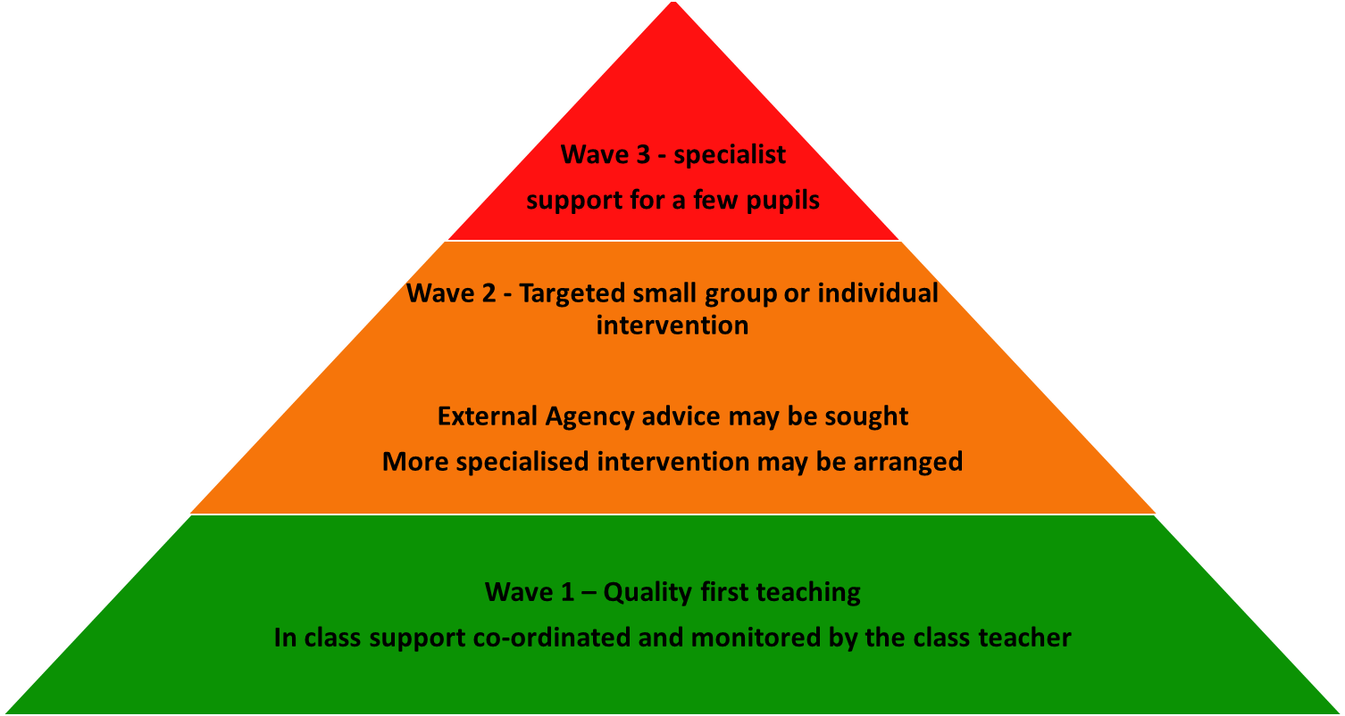

Parents are informed/consulted if their child receives Wave 2 or 3 support.
Wave 1 Support: Quality First Teaching
SEND pupils are included in all aspects of school life. The differing needs of pupils are supported in class by our skilled teachers and teaching assistants; learning is differentiated; resources and additional support provided, and the classroom and school environment adapted to meet the needs of all our pupils.
The SENCO and other senior managers ensure high quality learning and support for pupils with SEND. This is achieved through a continued professional development programme for staff, regular monitoring of classroom practice, review of pupil progress and pupil’s work, and listening to pupil and parent views.
Some children with SEND may require additional, targeted support to enable their learning and access to school life, and this is where Wave 2 support begins.
Wave 2 Support: Targeted Small Group or Individual Intervention
Where pupils require additional support beyond the classroom, the Inclusion Team works with class teachers to provide additional assessment advice, resources, and intervention programmes to ensure pupils make or exceed expected progress.
Targeted interventions are provided on a 1:1 or group basis for children who need support to catch up with, or consolidate, their learning. Interventions used in school are selected to meet the range of pupil needs and include published intervention programmes, and teacher or SENCO directed support.
These support programmes are delivered by the class teacher or a trained teaching assistant. They may occur within or outside the classroom, and typically run for one or two terms, although some may continue for longer periods.

Wave 3 Support: Pupil Centred Planning
Some SEND pupils have more complex needs that require tailored personal support programmes. Seymour Primary School has a pupil centred approach to meeting the needs of such pupils.
Parents and pupils, when appropriate, are invited to regular Team Around the Child (TAC) meetings with the SENCO and class teacher. During these meetings, the needs of the pupil are discussed in detail, previous support and targets are evaluated, and a personal timetable for support is devised. Tailored support is provided for such pupils, to enable them make expected progress, and enjoy access to all aspect of school life.
Education Health and Care Plan
In a very few cases, when there is significant concern about the child, the decision is made that much more detailed information is needed. After consultation with the parents, class teacher and outside agencies the school may request assessment for an Educational Health and Care Plan (EHCP). The Local Education Authority looks at the evidence and decides whether the assessment is needed. If an assessment is carried out, it may lead to a formal Educational Health and Care Plan being issued. An annual review takes place within one year of the date of the EHCP. The procedures for inviting professionals to the meeting and the distribution of advice are followed as stipulated in the Code of Practice (2015).
Step 4: Review
Every half term, class teachers review their children’s progress and plan for their next steps. The impact of Wave 1 and 2 support is reviewed, and next steps to support behaviour and learning are planned. Members of the senior management team monitor pupil progress and behaviour, and will work with teachers to further support any child whose progress is of concern.
External agency review meetings: External agencies often revisit school to review a child’s support and progress. This may involve re-assessment, consultation with parents and alteration of provision.
When additional support has resulted in little progress, then a child may move up to the next Wave of support.
When additional support results in expected progress, then a child will move down to the previous Wave of support.
STAFF ROLES & RESPONSIBILITIES
Class teacher:

- makes initial identification of a child with special educational needs;
- differentiates the curriculum in all subject areas where appropriate;
- monitors the progress of the child and regularly updates any assessments;
- identifies interventions with the SENCO;
- ensures the SENCO is kept well informed of any issues that arise between reviews;
- liaises informally with parents regarding their child’s progress towards targets
- maintains ongoing communication with the child regarding progress;
- attends regular Team Around the Child meetings to discuss the child’s support (for those at Wave 3)

Teaching Assistant:

- works at the direction of the class teacher and SENCO;
- delivers intervention programmes under the guidance of a teacher;
- supports pupils in class, whilst developing independence

In our school, the SENCO:

- manages the day-to-day operation of the policy;
- supports and advises colleagues;
- co-ordinates the provision for and manages the responses to children's special needs;
- oversees the records of all children with special educational needs;
- oversees the writing, distribution and review of individual timetables and plans;
- acts as the link with parents and carers, external agencies and other support agencies;
- monitors and evaluates the special educational needs provision;
- monitors and evaluates attainment and progress of pupils;
- manages a range of resources, both human and material, to enable appropriate provision to be made for children with special educational needs;
- contributes to the professional development of all staff.

In our school, the Headteacher:

- ensures that all children make the best possible progress;
- monitors teaching, attainment and progress of pupils;
- ensures that the Code of Practice is complied with;
- reports to the Governing Body on the provision for children with special educational needs and disabilities.

In our school, the Governors:

- monitor the school’s SEN policy;
- ensure they are up to date and knowledgeable about the school’s SEN provision, including how funding, equipment and personnel resources are deployed;
- measure the impact of actions taken and money spent.

